Background Information: You can classify rock samples based on the percentages of certain key minerals. For example, look at the chart and find the phaneritic, or coarse-grained, rock diorite. Read vertically upward onto the mineral composition part of the chart. Here you can see that a diorite is composed of 0-5% biotite, 5-20% hornblende, 0- 15% augite, and 20-70% plagioclase. These percentages are ranges. Different diorites have different amounts of these minerals.

Igneous Classification Chart
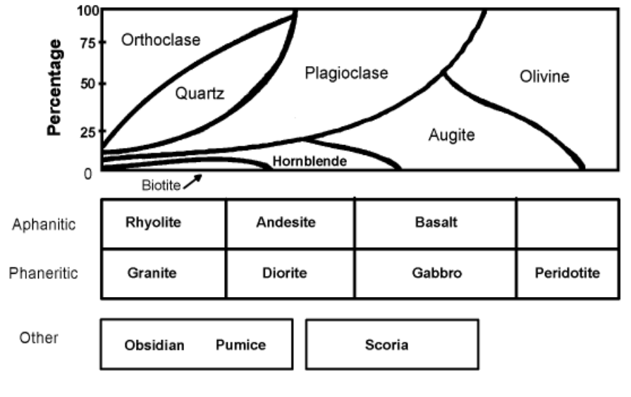

Rock | Texture | Minerals | Percentage (%) Range
Granite
Gabbro
Peridotite
Rhyolite
Andesite
Basalt
Objective: To identify the minerals in igneous rocks.

Procedure: Use the Igneous Classification Chart to determine the mineral composition of each igneous Rock.
Phaneritic = coarse-grained
aphanitic = fine-grained

