Big Idea on Historical Models of the Universe
S6E1. Obtain, evaluate, and communicate information about current scientific views of the universe and how those views evolved.
- Ask questions to determine changes in models of Earth’s position in the solar system, and origins of the universe as evidence that scientific theories change with the addition of new information. (Clarification statement: Students should consider Earth’s position in geocentric and heliocentric models and the Big Bang as it describes the formation of the universe.)
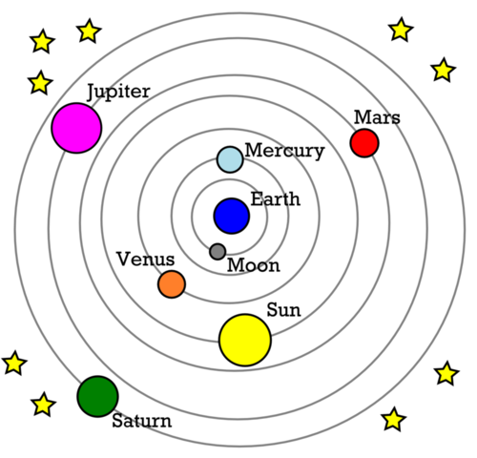
Ptolemy, an ancient Greek astronomer, thought that the Earth was at the center of the universe. This was known as the GEOCENTRIC or EARTH CENTERED theory.

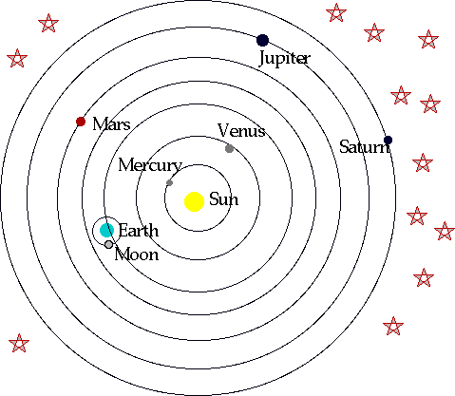
1500 years later, Copernicus, a Polish astronomer, correctly thought that the planets orbited the Sun. This is known as the HELIOCENTRIC or SUN CENTERED theory.

The BIG BANG theory states that the universe began with a tremendous expansion from a point of singularity about 13 billion years ago. Current studies show that the universe continues to expand.
