The BIG IDEA about AIR MASSES and FRONTS
c. Develop a model demonstrating the interaction between unequal heating and the rotation of the Earth that causes local and global wind systems.
- Air masses are characterized by moisture content and temperature.
- A front occurs where two air masses meet.
- Four major types of fronts are:
  - COLD
  - WARM
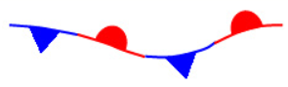
  - STATIONARY
  - OCCLUDED

- Differences in air pressure and movement of air masses cause different types of weather.

