Sixth Grade Science Name_________________
Unit #3 Study Guide
1. Why is the ozone layer so important?

2. Why is it difficult to breathe at high altitudes?

3. If you wanted to fly through a cloud, which atmospheric layer would you fly through?

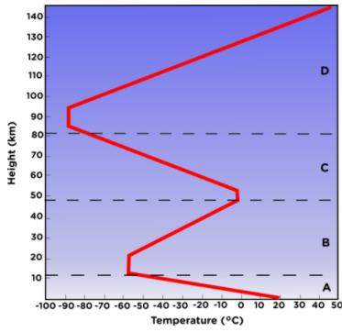
4.
Analyze the above chart to identify the following layers of the atmosphere.
Layer A – 0-10 km: ___________________.
Layer A Characteristic:
Layer B – 10-50 km: ___________________.
Layer B Characteristic:
Layer C – 50-80 km: ___________________.
Layer C Characteristic:
Layer D – 80-140 km: ___________________. Layer D Characteristic:
Layer E – higher than 140 km: _______________.
Layer E Characteristic:
5. A pot is heated on a stove. Which heat transfer process causes the metal handle of the pot to also become hot?

6. Angel stands in a swimming pool and notices that the water around his feet is a lot cooler than the water near the surface. Which process causes this difference in temperature?
7. The transfer of thermal energy by movement of particles through gases and liquids is ________________.
8. The transfer of thermal energy by direct contact is ________________.
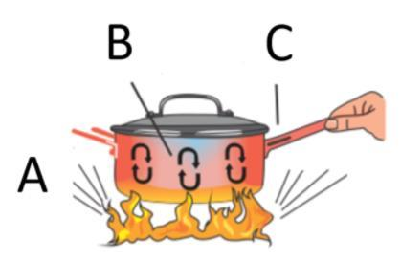
9. Label the letters on the diagram as a type of heat transfer, either conduction, convection or radiation.

10. Heat transfer always moves from a ___________ substance to a __________ substance.

11. Label the following with arrows, high and low pressure, a sun or moon to indicate time of day, and label the water and land as warm or cool.
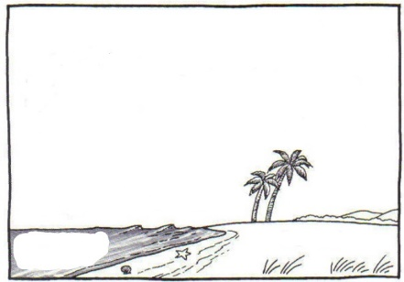
Sea Breeze Land Breeze

12. Warm air _______ because it is _______ dense.
Cold air ________ because it is ________dense.
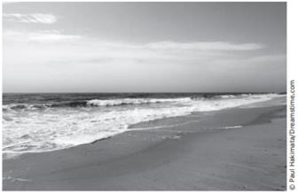
13. This photograph shows a beach on a partly sunny day. ___________ from the sun causes water to _________________ from the ocean.

14. Which is the best explanation for how air masses move across the United States?
The prevailing _____________ move air masses from west to ________ across the United States but may be deflected by the jet stream.
15. Complete the table by filling in the global wind that occurs at each latitude.
Latitude | Global Wind
0-30
30-60
60-90

16. Which global winds have the greatest impact on the weather in the US?

17. Differences in air ___________ affect the movement of air because air always moves from areas of ________ pressure to areas of _______ pressure.

18. The curving of air to the right in the Northern Hemisphere is caused by Earth’s ____________ and is called the __________ Effect.

19. Wind is the movement of air from areas of ________ pressure to areas of ______ pressure.

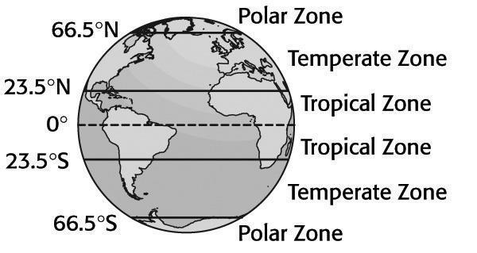
20. Use the picture to help you match the climate zone with the amount of sunlight it receives.
Climate Zone Amount of Sunlight
A. Polar Zone- ____Most sunlight
B. Temperate Zone- ____Least sunlight
C. Tropical Zone- ____Medium sunlight

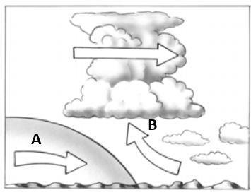
21. The air mass on the left formed over a polar region and the air mass on the right formed over a tropical region. Which type of front is at the front of air mass A?
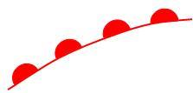
22. Label each of the following with the type of weather front it symbolizes.
A. _______________

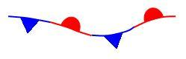
B. _______________
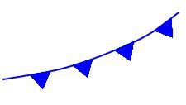

C. _______________

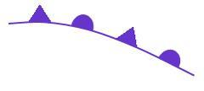
D. _______________

23. Where do hurricanes originate (start at)?

24. A dry, cold air mass would be called ________________________.
25. The boundary between cold and warm air masses is called a/an _____________.
26. When a warm air mass gently slides on top of a cold air mass, and you have drizzly rain followed by beautiful sunny weather, what front is it?
27. A/an ______________ is a large body of air that has the same properties as the Earth's surface over which it develops and has the same density and moisture content.

28. What type of weather will most likely result from a low-pressure weather system?

